I am Poems

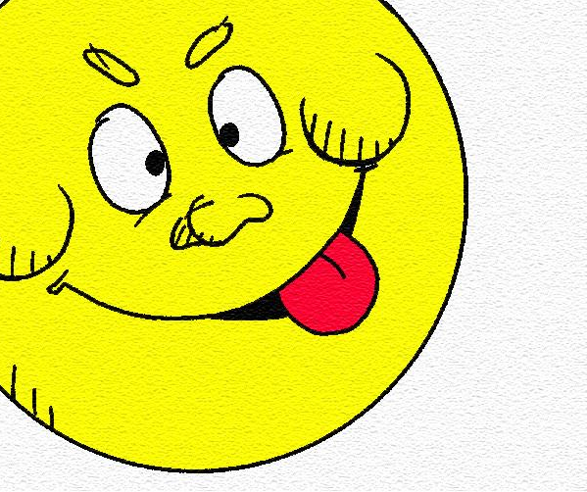
I Am

I am (two special characteristics)
I wonder (something you are actually curious about)
I hear (an imaginary sound)
I see (an imaginary sight)
I want (an actual desire)
I am (the first line of the poem restated)

I pretend (something you actually pretend to do)
I feel (a feeling about something imaginary)
I touch (an imaginary touch)
I worry (something that really bothers you)
I cry (something that makes you very sad)
I am (the first line of the poem repeated)

I understand (something you know is true)
I say (something you believe in)
I dream (something you actually dream about)
I try (something you really make an effort about)
I hope (something you actually hope for)
I am (the first line of the poem repeated)

